**Visualizing Location-Based Data**

Using Google Fusion Tables

Many events are dependent on location, and having the ability to show these data in the context of their geographic origins can reveal trends that may otherwise be unobserved. Luckily, modern interfaces with Google Maps allow an unexperienced user to generate such content within minutes. No special software is required. Only a spreadsheet program and a web browser are needed.

This document provides a guide for geocoding location based data and visualizing with Google Maps by examining reports of UFO sightings in Texas taken from The National UFO Reporting Center Online Database <http://www.nuforc.org/webreports.html>

1. Format data. This example will use a CSV file. Below is a table of the data format:

|  |  |  |  |  |  |  |
| --- | --- | --- | --- | --- | --- | --- |
| Date | Location | State | Shape | Time | Summary | Upload Date |
| 2/19/2015 | Walburg | TX | Cigar | 1 minute | Two bright shiny white cylindrical cigar-shaped objects rounded nose and tails. | 2/20/2015 |
| 2/18/2015 | Helotes | TX | Chevron | 4-5 seconds | Translucent white in color and bird shape. | 2/20/2015 |
| 2/18/2015 | Frost | TX | Light | 3 hours | Assom ((sic. "Awesome")) i want 2 drive. | 2/20/2015 |
| 2/10/2015 | Midland | TX | Disk | ~5 seconds | UFO over Midland, Texas. | 2/12/2015 |

Notice that in addition to the location (city) that the event occurred in, there are several other details about the event. The date, time, shape, and description of the event may provide relevant details for detecting trends.

1. Create a Google Fusion Table. You will need to access a Google Drive Account and enable the Google Fusion Tables app to do this.

* Select  from on the Google Drive interface
* Select 
* Search for and 

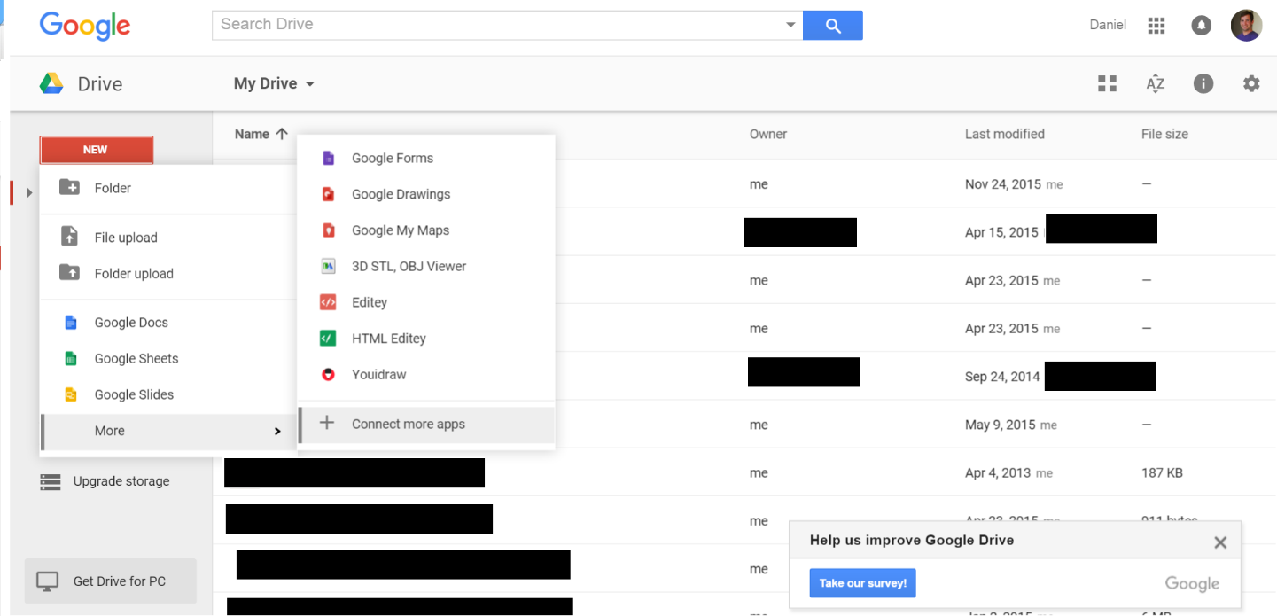

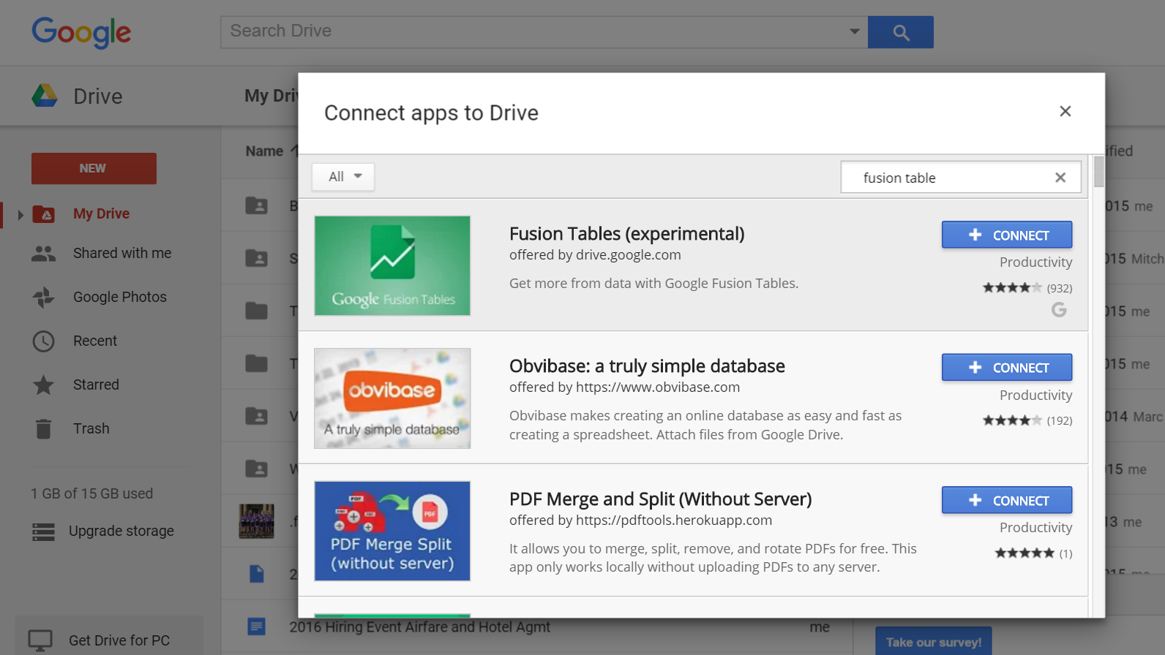

1. Import data. In this example, the input is a “UFO.csv” file but you may use many different formats.

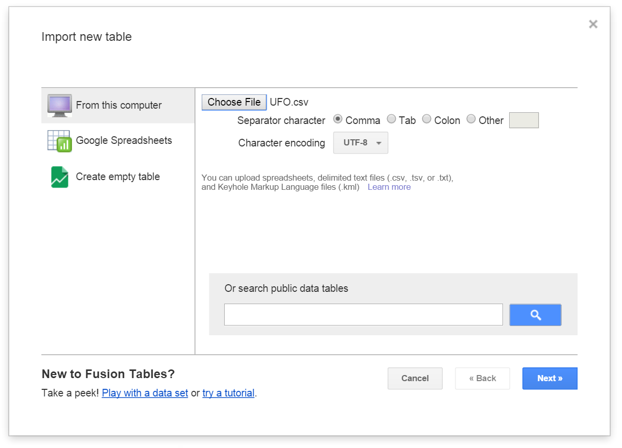

1. Tag Location Data. Google is not smart enough (yet) to figure out which columns provide the relevant geographic data. You will need to tag the columns that contain locational reverences. Click the arrow on the column header to access the drop down menu.

* Select  . Change data type to location
* You must select “2 column location” and tag the latitude and longitude to use coordinate data

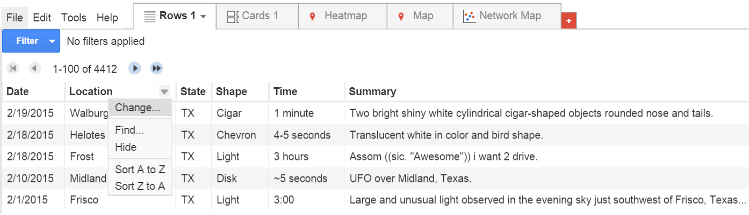

1. Geocode Data. Google will scan your location reference and convert these to a format that Google Maps will understand. The program will flag any ambiguous points. Sometimes a contextual hint will be required I.E. “Cities in Texas.” In this example, the location data is the names of cities. However, you may use GPS coordinate data or other locational data.

* From the Fusion Table interface, select on the menu bar.
* Selectfrom the dropdown menu.

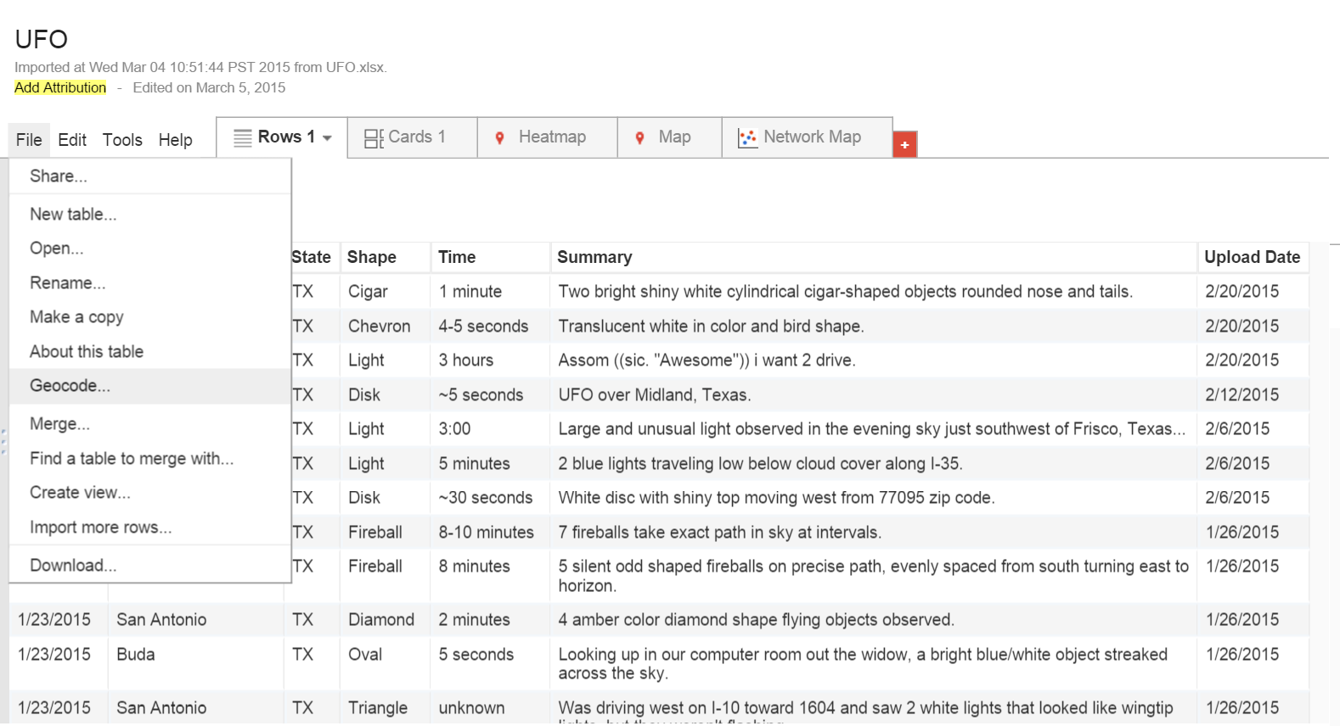

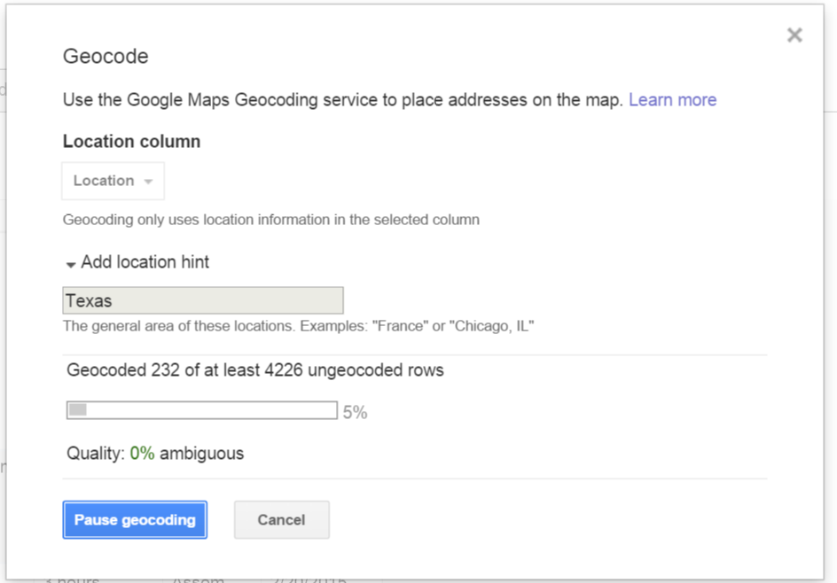

1. Create A Map.

* Press the red  button to create a new tab and select .

From here you can select options such the type of map. A **Feature Map** displays pins of all data points with associated data accessible by clicking on the point. A **Heat Map** generates a color coded map useful for observing density of events, but the individual data will no longer be accessible.

You can access an interactive version of this map at <https://www.google.com/fusiontables/DataSource?docid=15319zrD0GjbFzU1EWgIhECZiQduo6PAjMO03KsRm>

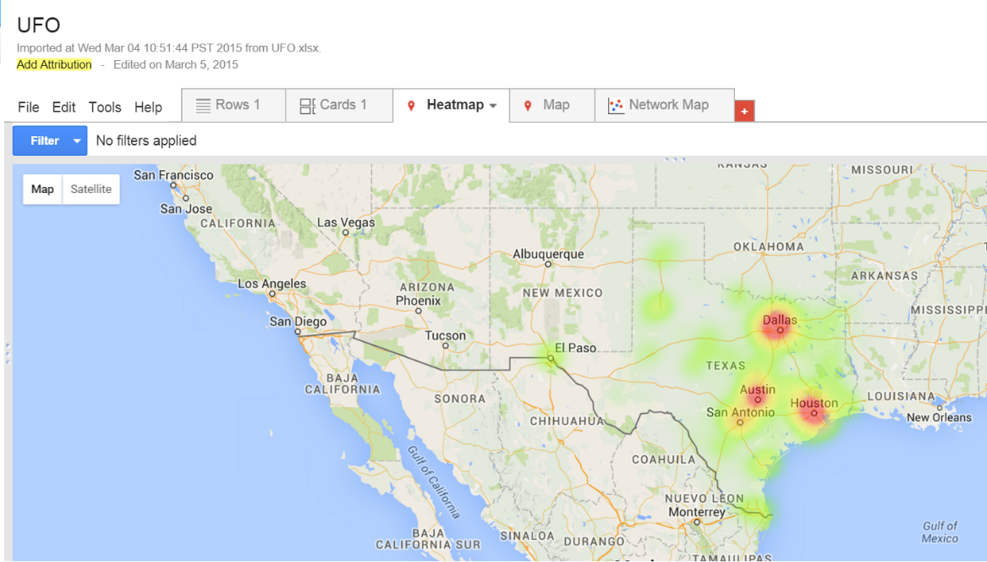

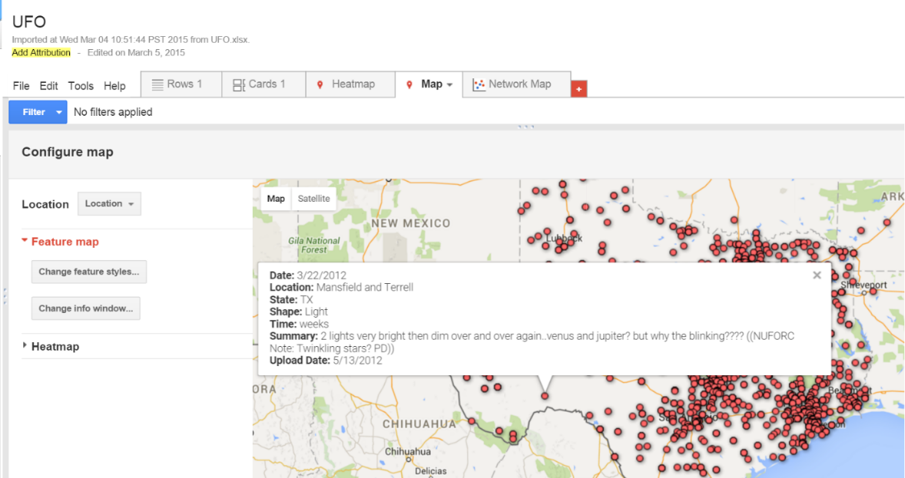

Try this with your own data. Let us know what you create on Twitter [@HUBioinformatic](http://twitter.com/HUBioinformatic)